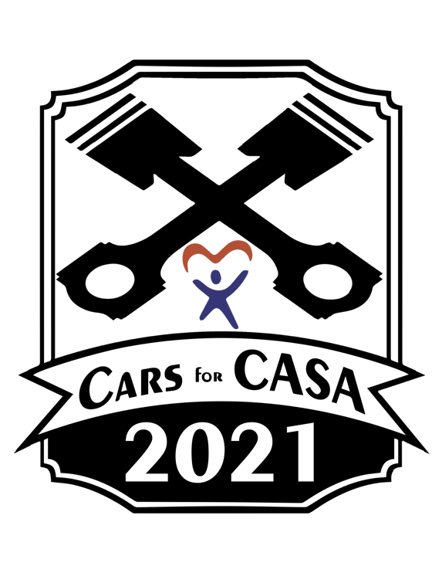
Cars for CASA 2021

Sponsorship Application

Dear Friends of CASA,

The 5th Annual Cars for CASA Car Show is officially on the calendar! We’re joining with the Buchanan Street Strolls on September 12th from 12 pm to 4 pm. This is Boone County CASA’s primary fundraiser this year and we are looking to break our attendance records. There will be food trucks, live music, a 50/50 raffle, and so much more! This is a rain or shine event – please follow our event page on Facebook for all the updates and information for the show.

Boone County CASA needs your support as we are currently supporting 80 children and their families. Children who have been abused and neglected often slip through the cracks in the judicial system. CASA advocates change that by ensuring that the children’s voices are heard. CASA is the only volunteer organization that empowers everyday citizens to become appointed members of the court. Appointed by judges, CASA advocates are assigned to cases and commit to staying on those cases until the children are placed in safe, permanent homes. With the help of their CASA advocates, these children have a better opportunity to find stability in a loving and safe family.

We hope that you consider sponsoring the 2021 Cars for CASA Car Show and in turn, supporting Boone County CASA as we work hard to help the little ones in our community. We look forward to seeing you at this year’s event on September 12th!

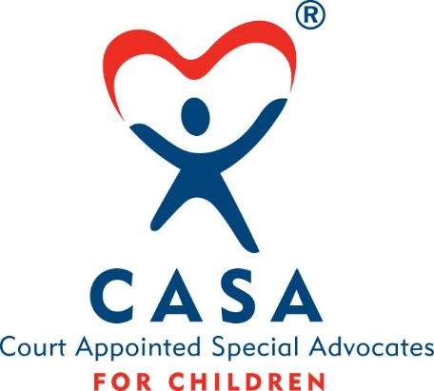
Sincerely,
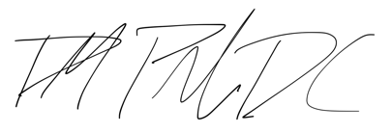

Dr. Derek M Prado, DC
Board of Directors, Boone County CASA

If interested in being an Event Sponsor for Cars for CASA,
please fill out the information below and return to:
Boone County CASA, 130 S. State St. Suite 209, Belvidere, IL 61008
Checks should be made payable to Boone County CASA
and are 100% tax deductible as a charitable contribution.

Company: Contact Name:
Address: City/St/Zip:
E-mail: Phone:

__ GOLD – $250 __ SILVER – $100
DJ Recognition at Show Business Name on T-Shirt
Business Logo on T-Shirt Business Name on Facebook Event Page
Business Logo on Facebook Event Page Gift Bag Items (50)
Gift Bag Items (50) Deadline: August 13th 2021
Deadline: August 13th 2021

__ BRONZE – $50 __ Donation – Amount $ ________
Gift Bag Items (50)
Deadline: September 3rd 2021

If interested in adding a gift bag item, please contact
Dr. Derek Prado at 815-544-5227 or at Cars4CASA@gmail.com

